1.SUM OF RANDOM NUMBERS WHICH ARE DIVISIBLE BY 2.

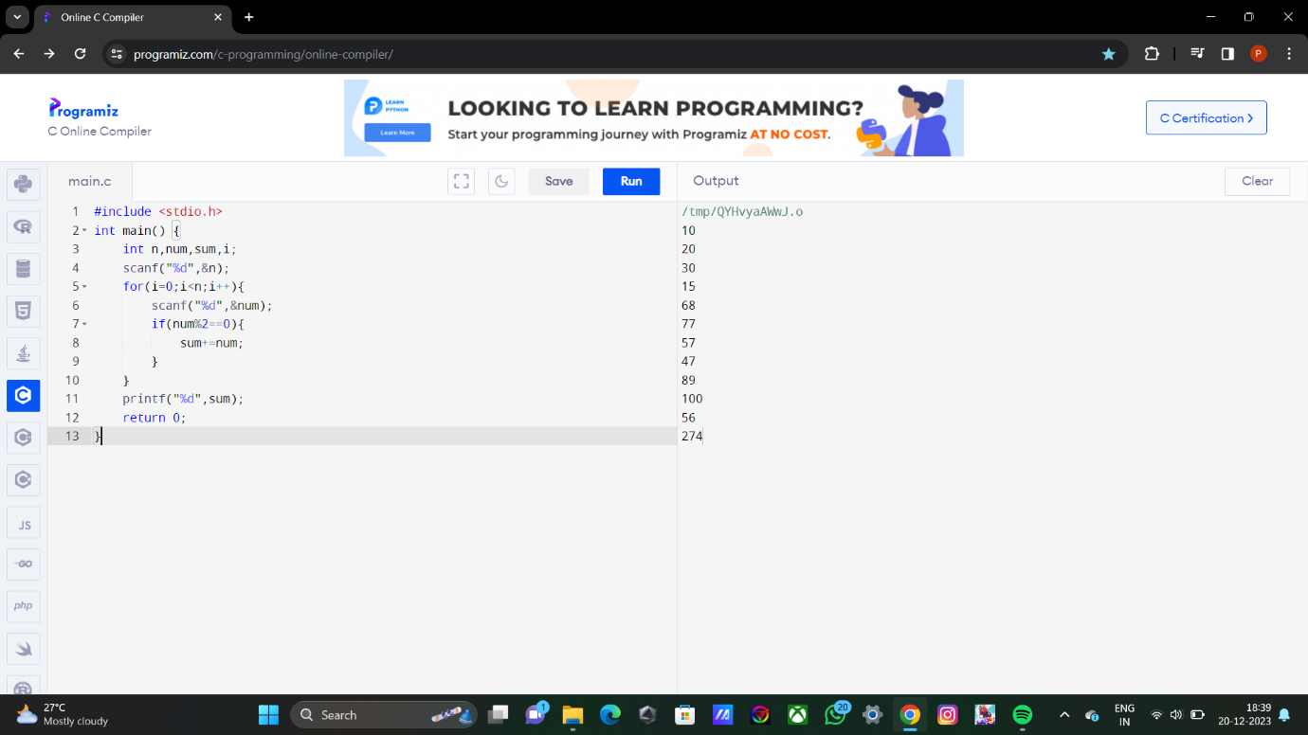

2. SUM OF RANDOM NUMBERS WHICH ARE DIVISIBLE BY 2.

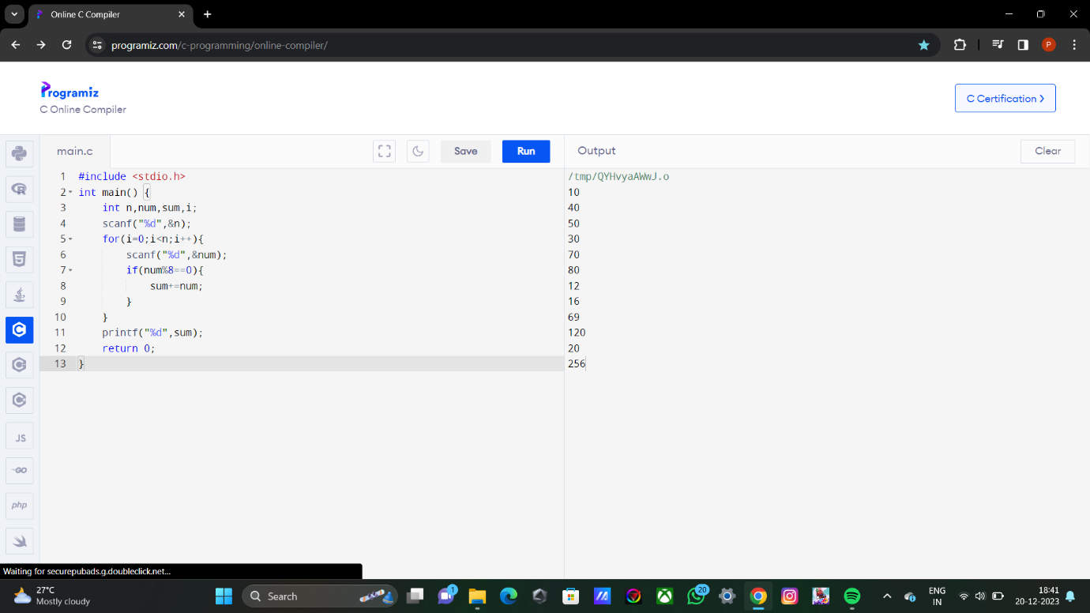

3. FIBONACCI SERIES OF “N” NUMBER OF TERMS.

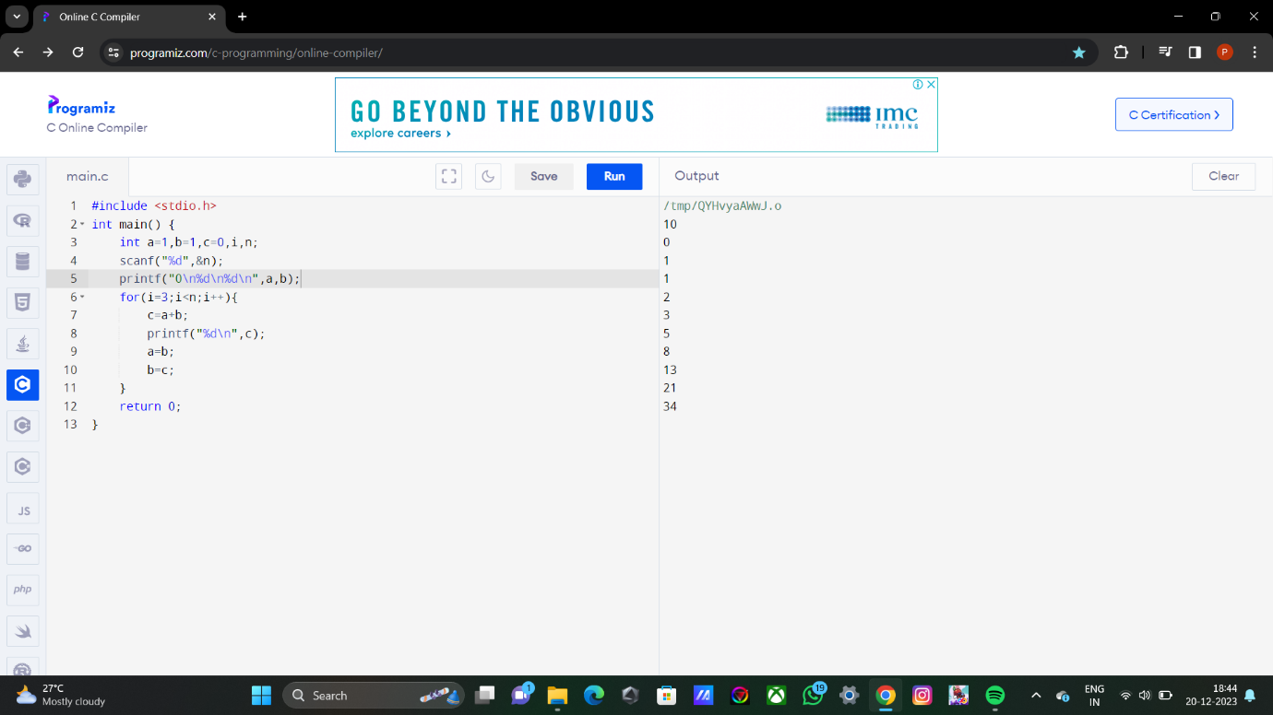

4. SUM OF FIBONNACI SERIES UPTO “N” NUMBER OF TERMS.

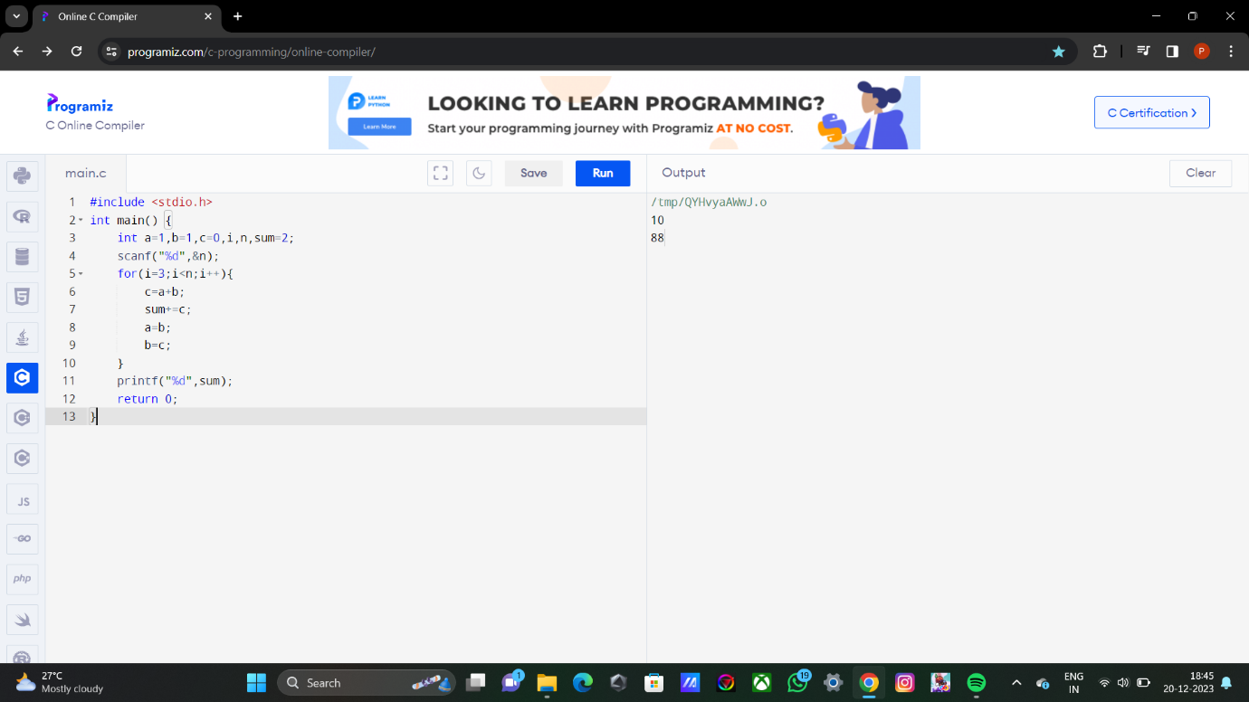

5. FACTORIAL USING RECURSION.

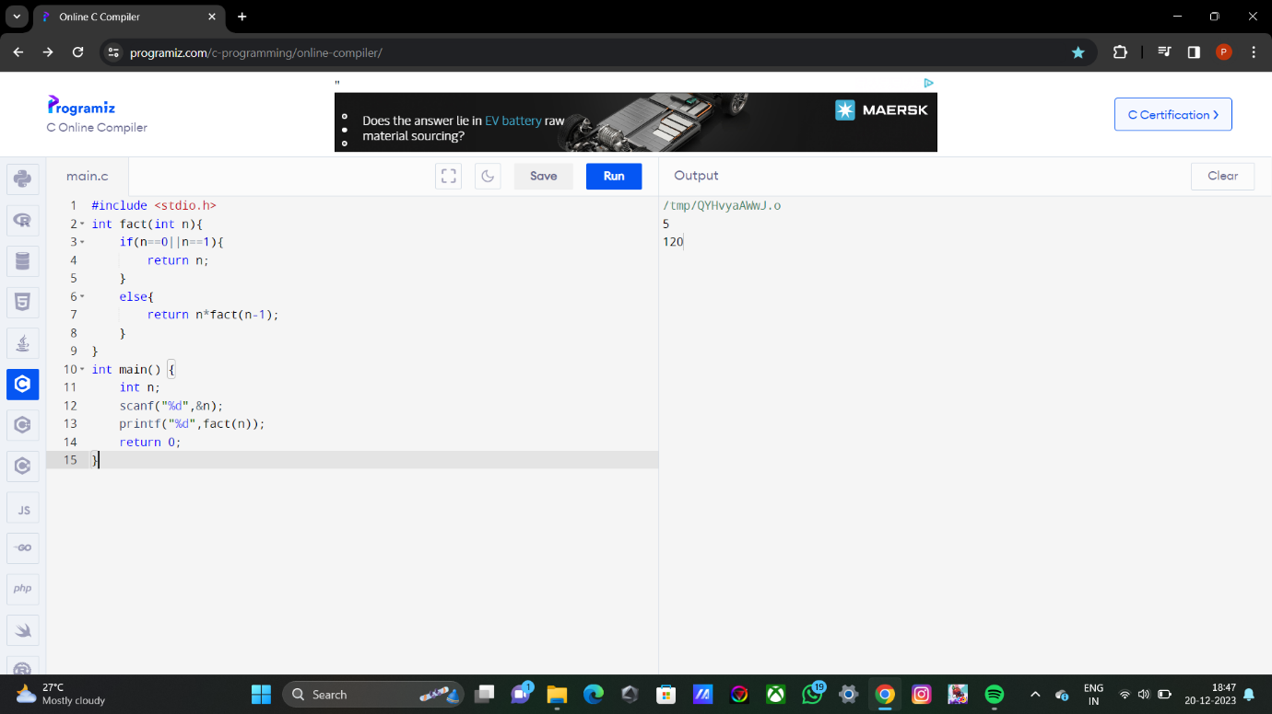

6. TO FIND EXPONENT OF A GIVEN POWER AND BASE USING RECURSION.

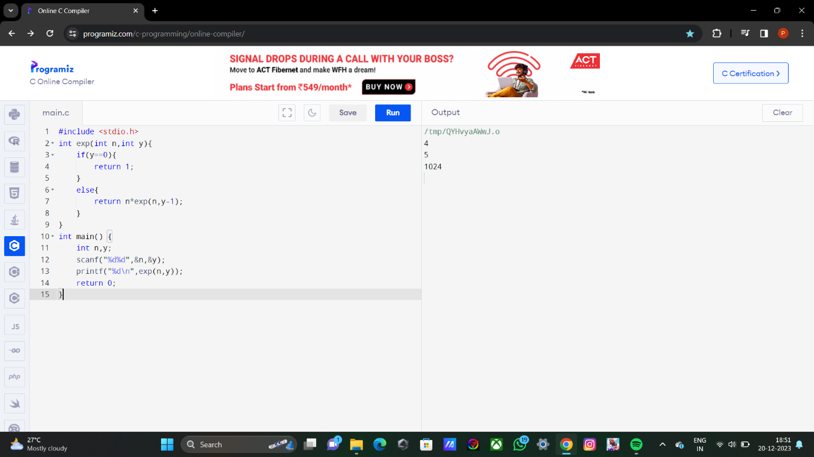

7. RECURSION PROGARM TO FING THE PRODUCT OF TWO NUMBERS.

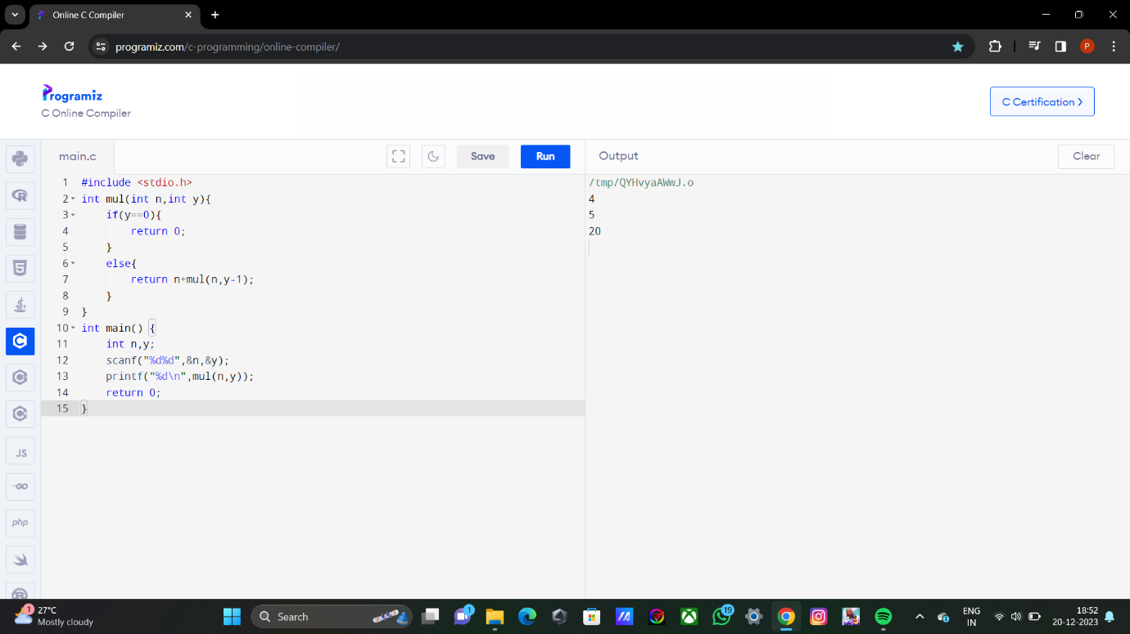

8. FIBONACCI SERIES USING RECURSION.

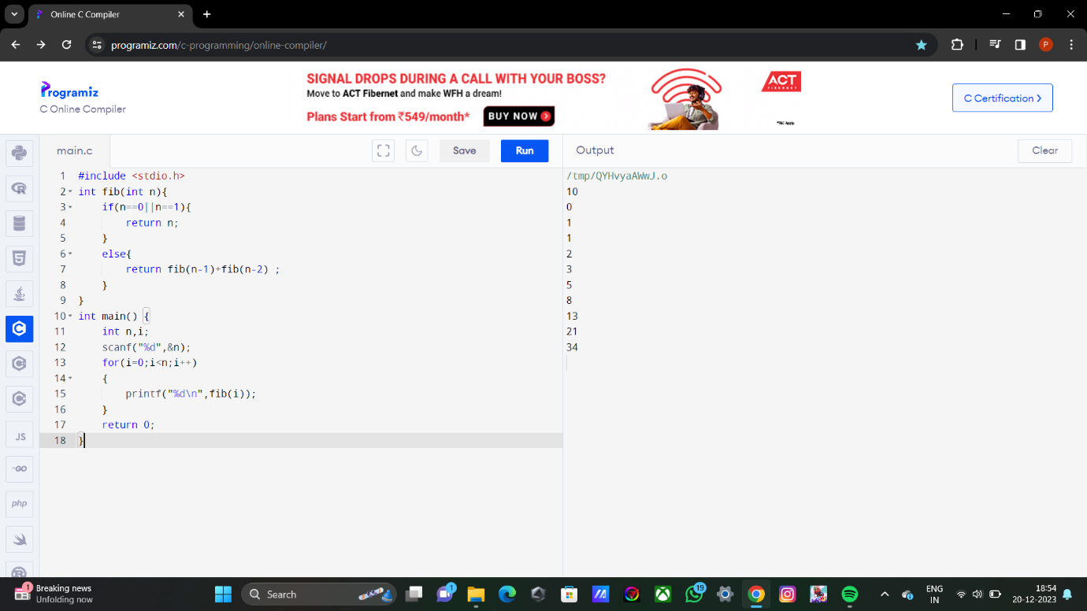

9. TO FIND SUM OF EVEN AND ODD NUMBERS IN A SET OF GIVEN NUMBERS.

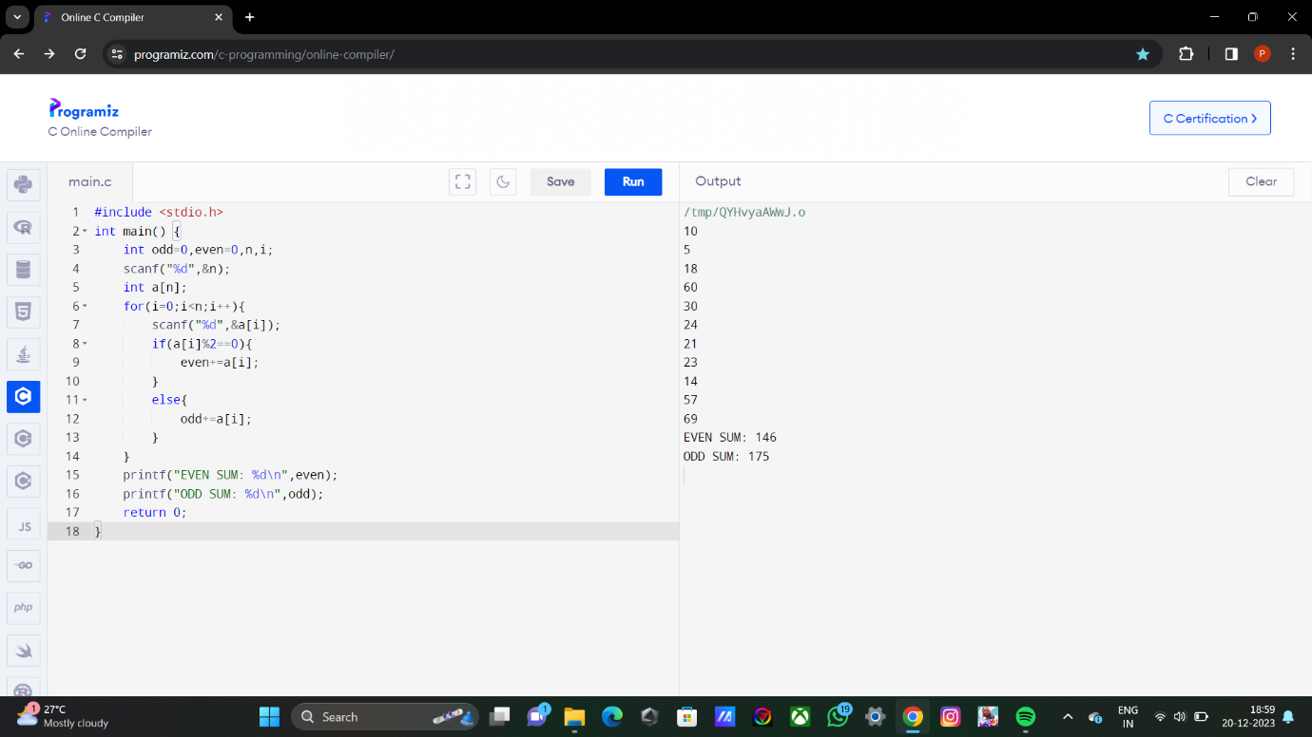

10. SUM OF “N” RANDOM NATURAL NUMBERS.

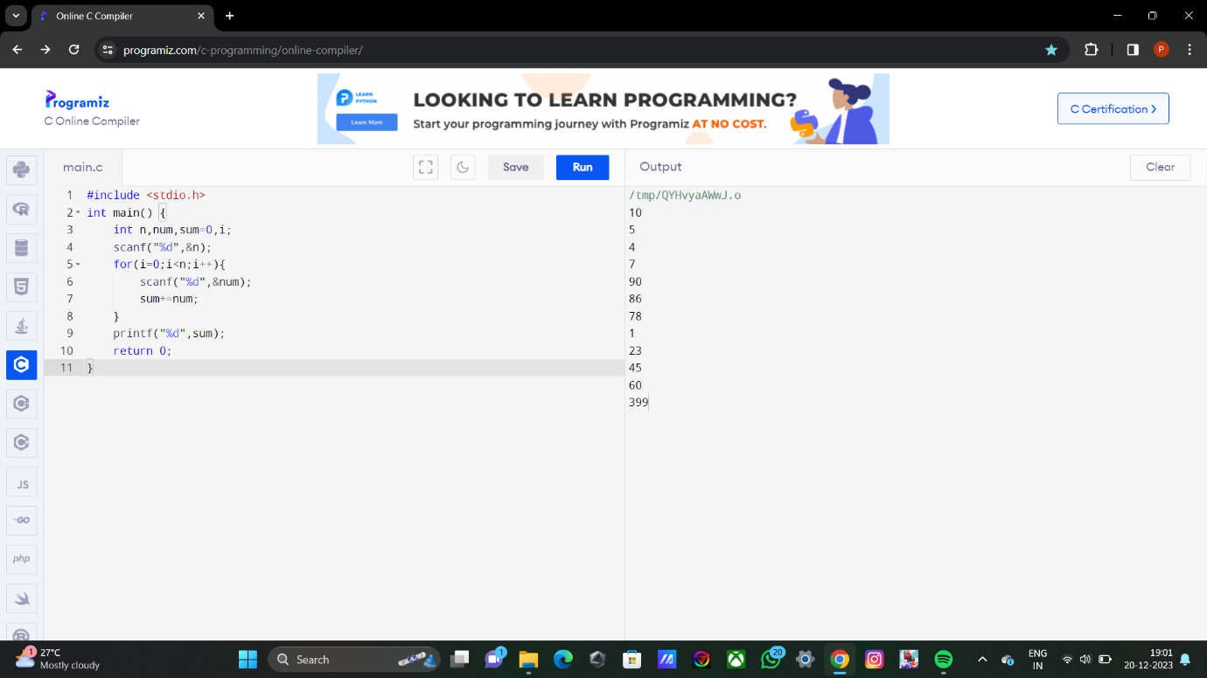

11. SUM OF TWO NUMBERS.

